**F. Y. B. Tech Academic Year 2021-22**

**Subject:** Basics of Electrical and Electronics Engineering **Trimester: 2**

**Name:** Shreerang Mhatre **Division: 11**

**Roll No:** 111056 **Batch: K3**

**Experiment No: 1**

**Name of the Experiment**: Introduction to instruments and electronic components, Build and test Light Emitting diode Circuit on Breadboard.

**Performed Date: 10/12/2021**

**Submitted Date: 23/12/2021**



**Aim: Introduction to instruments and electronic components, Build and test Light Emitting diode Circuit on Breadboard**

**Prerequisite:**

* Understanding of different electrical parameters

**Objectives:**

* To identify basic electronic components and understand their functions
* To recognize different instruments and use them to measure various parameters

**Components and equipment required:**

Digital multimeter, breadboard, transformer, relays, resistors, capacitors, inductors, diodes, CRO, function generator, power supply etc.

**Theory:**

**Electronic Components:**

Electronic Components are of two types

1. Active Components: Active electronic components are able to amplify or process an electrical signal. Examples: Diodes and transistors
2. Passive Components: Passive electronic components are not able to amplify or process an electrical signal by themselves. Examples: Resistor, Capacitor, Inductor, Switch, Cables.

**Passive Components:**

**Resistor:**

The flow of charge i.e. current through any material encounters an opposition called resistance of the material. It is measured in ohms (Ω) and its symbol is shown in fig. 1.1.

Resistance of a metallic wire is given by where ρ = specific resistivity = constant, *l* = length of a wire and A = area of cross-section of wire.

In some parts of electronic circuits, resistance is deliberately introduced. The device or component to do this is called a resistor.



**Fig. 1.1 Symbol of Resistor**

Some resistors are large enough in size to have their resistance value printed on the body. But some resistors are too small in size that values cannot be printed on them. So a colour coding system is used to indicate their values. The four colour bands are printed on the resistor. The value associated with each colour is shown in table 1.1.

**Table 1.1 Colour Coding Chart**

|  |  |  |  |
| --- | --- | --- | --- |
| **Colour** | **Digit** | **Multiplier** | **Tolerance** |
| **Black** | **0** | **100** | **-** |
| **Brown** | **1** | **101** | **1** |
| **Red** | **2** | **102** | **2** |
| **Orange** | **3** | **103** | **-** |
| **Yellow** | **4** | **104** | **-** |
| **Green** | **5** | **105** | **0.5** |
| **Blue** | **6** | **106** | **0.25** |
| **Violet** | **7** | **107** | **0.1** |
| **Grey** | **8** | **108** | **-** |
| **White** | **9** | **109** | **-** |
| **Gold** | **-** | **10-1** | **5** |
| **Silver** | **-** | **10-2** | **10** |
| **None** | **-** | **-** | **20** |

**Classification of resistors:**

Figure 1.2 shows various types of resistors. As seen in the figure, resistors are divided into linear and non-linear type. Linear resistors are further divided into fixed and variable. Non-linear resistors are mainly used as sensors in various applications.

**Capacitor:**

A capacitor (originally known as a condenser) is used to store energy electrostatically in an electric field between a pair of conductors called ‘plates’. The ability of a capacitor to store charge is measured by its capacitance. Unit of capacitance is Farad. Fig. 1.3 shows the symbol of capacitor.

A capacitor offers low impedance to ac but very high impedance to dc. So it is used to couple alternating voltage from one circuit to another while at the same time blocking the dc. It is also used as a bypass capacitor where it does not allow ac to go through the circuit by providing an alternate path to it. Capacitor is also used in tuning circuits along with an inductor.

**Classification of resistors:**

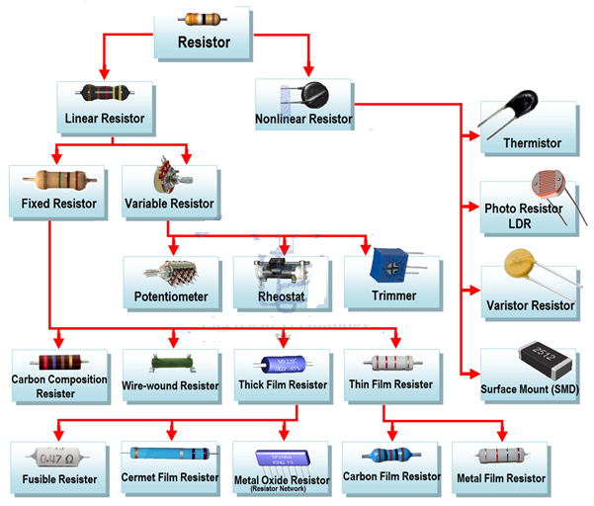

**Fig. 1.2: types of resistors**

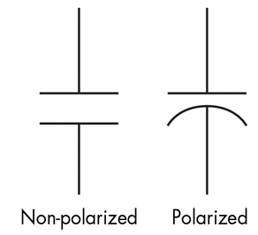

**Fig. 1.3: Symbol of capacitor**

**Classification of capacitors:**

A capacitor consists of two conducting plates separated by an insulating material called dielectric. Since two plates can be of many different conducting materials and dielectric can be of different insulating materials, there are many types of capacitors. Main types of capacitor are fixed and variable. As shown in fig. 1.4, fixed capacitors are further divided into polar and non-polar capacitors.

Non-Polar

Polar

Film Capacitor

Electrolytic

Fixed Capacitor

Ceramic

Super









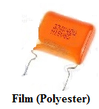  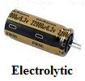 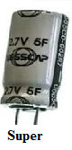

**Fig. 1.4 Types of capacitors**

**Inductors:**

When current flows through a coil, it generates a magnetic field. This magnetic field reacts so as to oppose any changes in current. This reaction of the magnetic field of trying to keep current flow at steady rate is known as inductance and the force it develops is called induced emf.an electronic component producing inductance is called an inductor. Fig. 1.5 shows symbol of inductor. Inductance is measured in Henry (H).

C:\Users\Administrator\AppData\Local\Microsoft\Windows\INetCache\Content.Word\induktansi.png

**Fig. 1.5: Symbol of Inductor**

**Classification of inductors:**

Inductors are classified as fixed and variable. Different types of inductors are available for different types of applications. Some types are shown in fig. 1.6.

Inductors





Fixed

Variable





Air-core

Cored

Slug-tuned

Tapped

 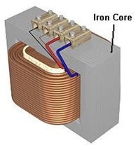 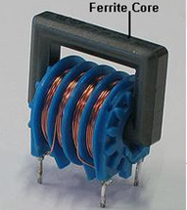 

**Fig. 1.6 Types of inductor**

**Active Components:**

**Diode:**

If a piece of P-type semiconductor material is joined to a piece of N-type semiconductor material such that crystal structure remains continuous at the boundary, then a P-N junction is formed. Such a P-N junction forms a very useful device called a semiconductor diode. Fig. 1.7 shows symbol of diode. The most important characteristic of a diode is that it allows unidirectional flow of current. It conducts well in forward direction and poorly in reverse direction. There are different types of diodes shown in fig. 1.8 although the working principal is more or less same.



**Anode Cathode**

**Fig. 1.7: Symbol of diode**

Various types of diodes are:

1. PN junction diode 2. Zener diode 3. Tunnel diode

4. Schottky diode 5. Varactor diode 6. LED

7. Photo diode

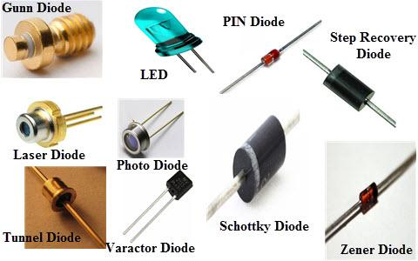

**Fig. 1.8 Types of diodes**

**Electronic Instruments:**

**Cathode Ray Oscilloscope:**

The cathode-ray oscilloscope (CRO) is a common laboratory instrument that provides accurate time and amplitude measurements of voltage signals over a wide range of frequencies. Its reliability, stability and ease of operation make it suitable as a general purpose laboratory instrument. CRO is used for voltage measurement, current measurement, examination of waveform, measurement of phase and frequency, component testing etc. Figure 1.9 shows front panel of CRO.

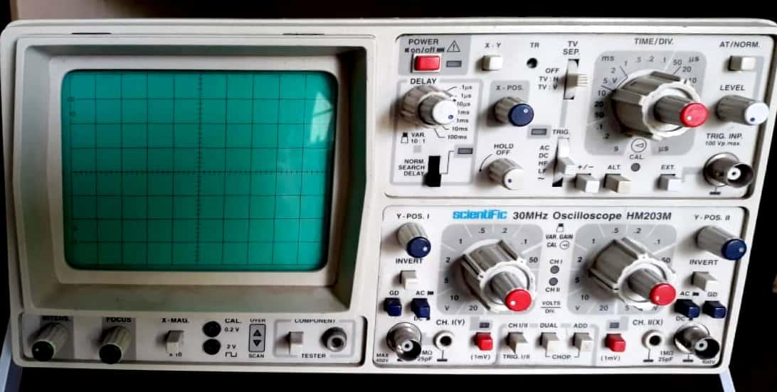

**Fig. 1.9: Front panel of CRO**

Various controls of CRO are as follows

1. **Intensity:** to adjust the brightness of the trace
2. **Focus:** to adjust the sharpness of the trace
3. **X-position:** moves the trace horizontally
4. **Vertical position:** moves the trace vertically
5. **Volt/div:** to control the overall vertical "height" of the trace
6. **AC/GND/DC:** GND is used to check the ground level of the trace. AC/ DC provides coupling of the signal without or with dc voltage.
7. **LEVEL:** to be adjusted slightly to obtain a stable trace
8. **TIME/DIV :** to control the sweep speed of the electron beam
9. **MONO/DUAL:** for dual trace operation

**Function Generator:**

Function generator is the equipment which supplies ac voltage. This voltage is used as a signal to test working of different electronic circuits such as amplifiers. Frequency of ac signal supplied by function generator can be varied. Straightforward signal generators such as RF signal generators or simple audio oscillators focus on producing good sine waves, but in many cases other waveforms are needed. In addition to producing sine waves, function generators may typically produce other repetitive waveforms including saw-tooth and triangular waveforms, square waves, and pulses.Fig. 1.10 shows the front panel of function register**.**

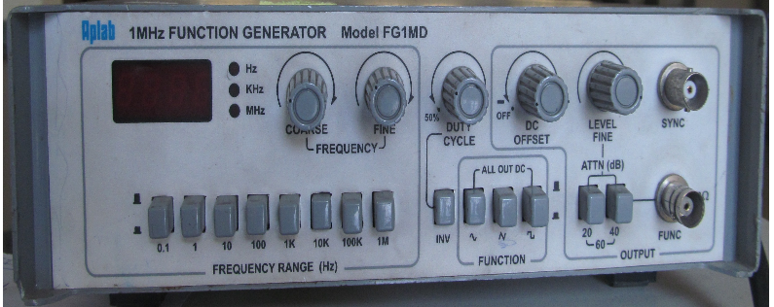

**Fig. 1.10: Front panel of function register**

**Multi-meter**:

A digital multi-meter (DMM) is a test tool used to measure different types of electrical quantities. This is a hand-held device which is very useful to detect faults or to provide field measurements at a high degree of accuracy. It is capable of providing several measurements like alternating voltage, direct voltage, alternating current, direct current, resistance (Ohms), capacitance (Farads) etc. Continuity testing can also be done using multi-meter. Fig. 1.11 shows the details on front panel of multi-meter.

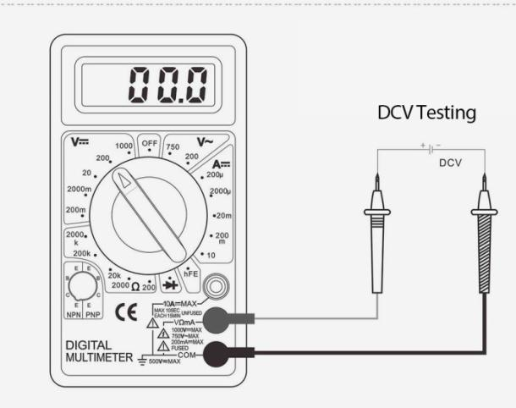

**Fig. 1.11: Front panel of digital multi-meter**

**Procedure:**

**Measurement of resistance using colour code:**

1. Write the value of the first band from colour code table which indicate the first significant digit.
2. For second significant digit, write the value of second colour band from colour code table.
3. Next band represent the number of zeroes. Write the value of third colour band from table and add the number of zeroes depending on the value after second significant digit. In case the third band is gold or silver, it represents a multiplying factor of 0.1 or 0.01 respectively.
4. Fourth band represent tolerance. Match the value of fourth band and add it in value derived from first three bands.
5. **Measurement of resistance using multi-meter:**
6. To measure the value of resistance from multi-meter, set the knob on suitable range of resistance.
7. Place the connectors of multi-meter on both terminals of resistors and note the resistance from display of multi-meter.
8. Compare the value of same resistor by both method and calculate the difference.
9. **Measurement of amplitude and frequency of sinusoidal signal:**
   1. Adjust sine wave signal of 1 V peak amplitude and 1 kHz frequency.
   2. Observe the same using CRO and measure its amplitude and frequency using CRO.
   3. Vary amplitude and frequency of the signal and note down the same in observation table.

**Breadboard Basics and Connections**

**What is Breadboard?**

A breadboard is a circuit board that is used to make temporary circuits. It is a device having electronics and test circuit designs. The electronic elements inside the electronic circuits can be interchanged by inserting the terminals and leads into holes and later connecting it with the help of appropriate wires. The device has stripes of metal below the board that connects the holes placed on the top of the board. The connections of the breadboard are mostly temporary and the elements can further be reassembled and reused without any damage. Breadboards are generally used in electrical engineering. Engineers make use of breadboards in order to test different products made by them. Using breadboard is the most efficient way of testing and also they are cost effective. They can be reused again and again for the purpose of testing. Today, starting from tiny analog, digital circuits to big complicated CPU’s everything can be tested with the help of this.

Breadboards earlier were made of copper wires or terminal strips. These days it is made up of white plastic and is a breadboard that can be plugged. Breadboards are solder less and they are made of two kinds of strips i.e. terminal and bus strips. Terminal strips help in holding the electronic elements while the bus strip is used to power electric power to all the electronic components. You can find manufacturers selling solder less breadboards very easily, some manufacturers sell the bust and terminal strips separately and some sell it together.

**Breadboard Basics:**

A breadboard is a circuit which if of a temporary nature used for the purpose of testing and prototyping circuits. It is easy to prototype circuits with the help of breadboards because it is fast and easy. Breadboards are generally used to test circuits. As this device is having holes in it. In order to form a circuit, wires are inserted simply inside the holes. An advantage of using a breadboard is that the positions of the wires can be changed if they are placed in a wrong order. In the below diagram you can see alphabets are used in order to identify vertical columns and numbers are used in order to identify vertical columns.

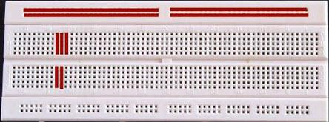

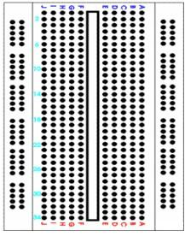 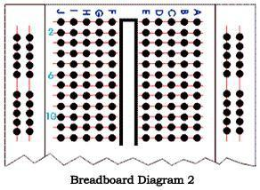

**Fig.1.11 Basics of Breadboard**

In the below diagram you can see both the vertical columns and horizontal to be connected internally. As soon as the power is turned on, the current flows through these internal connections. In the below diagram you can see how a resistor of 380 ohm and a LED are set up on the breadboard. A 9 volt battery is eventually attached to the LED light. Replace the current resistor with a resistor having 680 ohm you can see the resistance to be greater and the LED light to be dimmer.



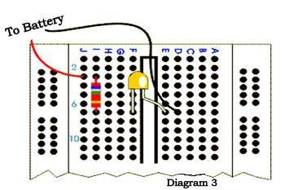

**Fig.1.12 Breadboard Connections**

**Breadboard Connections:**

A breadboard as mentioned before is used to make temporary circuit for testing and other purposes. The advantage of using a breadboard for testing is that connection can be changed if they are wrong. Also the parts of the circuit do not get damaged and can easily be reused. A breadboard generally consists of lots of holes so that wires can easily be pushed in. testing for almost every electronic projects starts from the breadboard. The breadboard has many tiny sockets likes holes arranged in a 0.1 grid. The leads that most elements have can easily be pushed inside these holes. The ICs are pushed inside across to the gap with their dot on the left. Standard wires cannot be used for breadboard as they get damaged easily and hence they require single core plastic coated wires that have 0.6mm diameter. Standard wires if used can also lead to damage of the board.

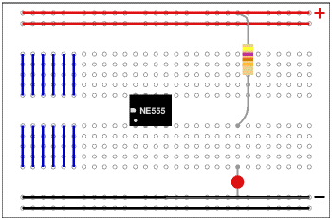

**Fig.1.13 Breadboard Connections**

The above diagram shows how the holes of a breadboard are connected. The bottom and the top rows are connected horizontally across as the red and the black line denotes. The power supply is connected to both the black and red rows. The other rows are connected in a vertical manner which consists of five rows each without any links to the across the centre. In this way there are separate blocks of connections to each of the ICs pin. Now this was the connection in a small breadboard. In case of large breadboards, there are breaks half way in the top and the bottom rows of the power supply. It is always better to link across the gap before you start building circuit. If you do not link it then that part of the circuit will not have any power supply.

**Virtual Breadboard:**

The virtual breadboard is generally used to test and design embedded software that is in a high level interactive circuit. It is used for prototyping the hardware from these designs. People find the virtual breadboard easier to utilize than the normal ones because it has a high approach. Also it is faster in tis working and helps in testing new ideas and circuit variations. Virtual breadboards are usually used in place of real breadboards because they are fast in working. Also it is fast in performing experiments and testing electronic embedded applications. Many experimenters prefer using virtual boards for experiments than real boards as its functioning is easy. The virtual board is popular in many universities around the world since the 1999.

A virtual breadboard is also called as VBB and makes use of [microcontrollers](http://www.electronicshub.org/microcontrollers/) featuring Makeable bread board designs. A virtual breadboard helps in making your projects easier and helps you do your experiments I a simple way. There are different versions of VBB that are available which users can use according to their need. It is always better to use a virtual breadboard than a real one as the virtual ones are more reliable. So if you are in a hurry and want immediate results it is advised that you make use of VBB.

## Steps to Building a Project on Breadboard Circuit

#### Step1: Know the Working of the Breadboard

#### Step2: Analyze the Circuit Diagram

#### Step 3: Get the Required Components

#### Step 4: Insert the Components on Breadboard

#### Step 5: Give the Power Supply

**Observation Table:**

1. **Resistance measurement**

|  |  |  |  |  |
| --- | --- | --- | --- | --- |
| **Sr. No.** | **Colour Band** | **Tolerance** | **Resistor Value using colour code with unit** | **Resistor value using multi-meter** |
| **1** | Green  Black  Brown  Silver | 10% | 500 Ohm | 500 Ohm |
| **2** | White  Black  Yellow  Gold | 5% | 900K Ohm | 900K Ohm |
| **3** | Yellow  Black  Green  Gold | 5% | 4000K Ohm | 4000K Ohm |
| **4** | Orange  Orange  Black  Brown  Violet | 0.1% | 3.3K Ohm | 3.3K Ohm |
| **5** | Brown  Green  Grey  Silver  Red | 2% | 1.58 Ohm | 1.58 Ohm |

1. **Amplitude and frequency measurement of sinusoidal signal**

|  |  |  |  |  |
| --- | --- | --- | --- | --- |
| **Sr. No.** | **Signal** | **Peak amplitude** | **Time period** | **Frequency** |
| **1** | Triangle | 6.2 div X 0.4V= 2.48V | 2 X 10= 20ms | 50 Hz |
| **2** | Triangle | 4 div X 1V=  4 div | 1.2 X 1= 1.2ms | 896 Hz |
| **3** | Sine | 1 div X 1V=  1V | 0.5 X 1= 0.5ms | 1K Hz |
| **4** | Sine | 3 div X 1V=  3V | 0.5 X 1= 0.5ms | 1K Hz |
| **5** | Square | 4.4 div X 1V=  4.4V | 2.9 X 1= 2.9ms | 35.7 Hz |

1. **Build a very simple circuit which lights up a single Light Emitting Diode (LED).**

**Components:**

|  |  |  |  |  |
| --- | --- | --- | --- | --- |
| **QTY** | **PART** | **DESIGNATOR** | **NOTES** | **TYPE** |
| **1** | 1k resistor (1000 ohm, brown - black - red) | **R1** | 1/4W, 5% or better Resistors | Resistors |
| **1** | 5mm red | **D1** | LED other color and sized LEDs could also be used, e.g. 3mm green LED Semiconductors | Semiconductor |

**Conclusion:**

**1)**In the given experiment we have learned and applied the basic electric components and got familiar with their features

**2)**We also learned about the colour bands of carbon composite resistor, CRO, Function generator and built a simple circuit on a bread board

**3)**We have also learned the application of photoresistor to drive the motor in clockwise and anticlockwise direction

* **Function Generator**

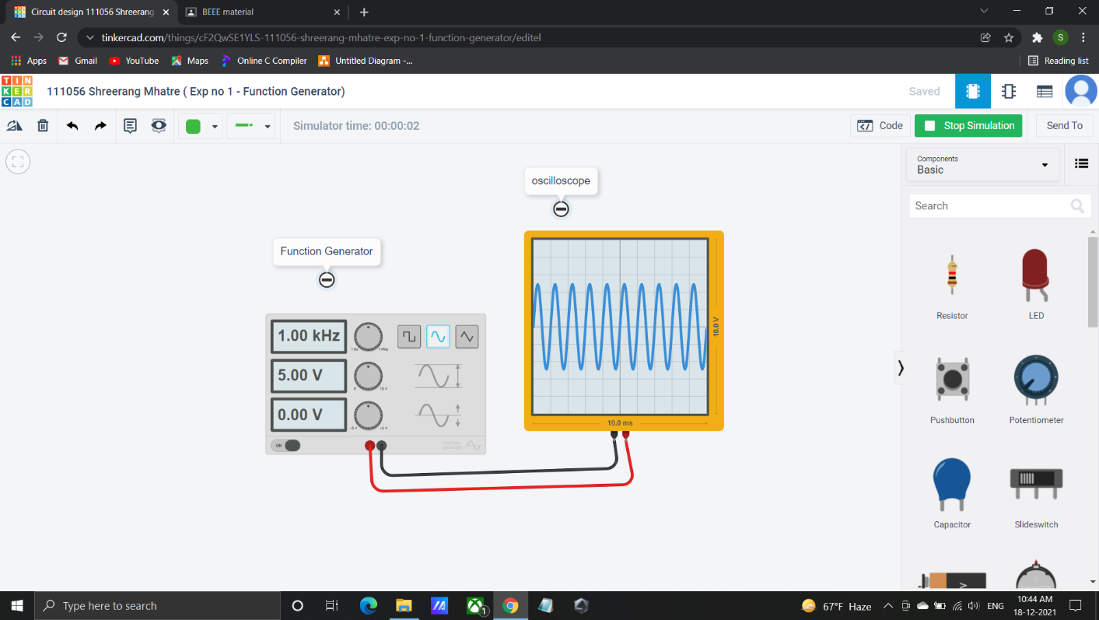

* **Light Emitting Diode (LED)**

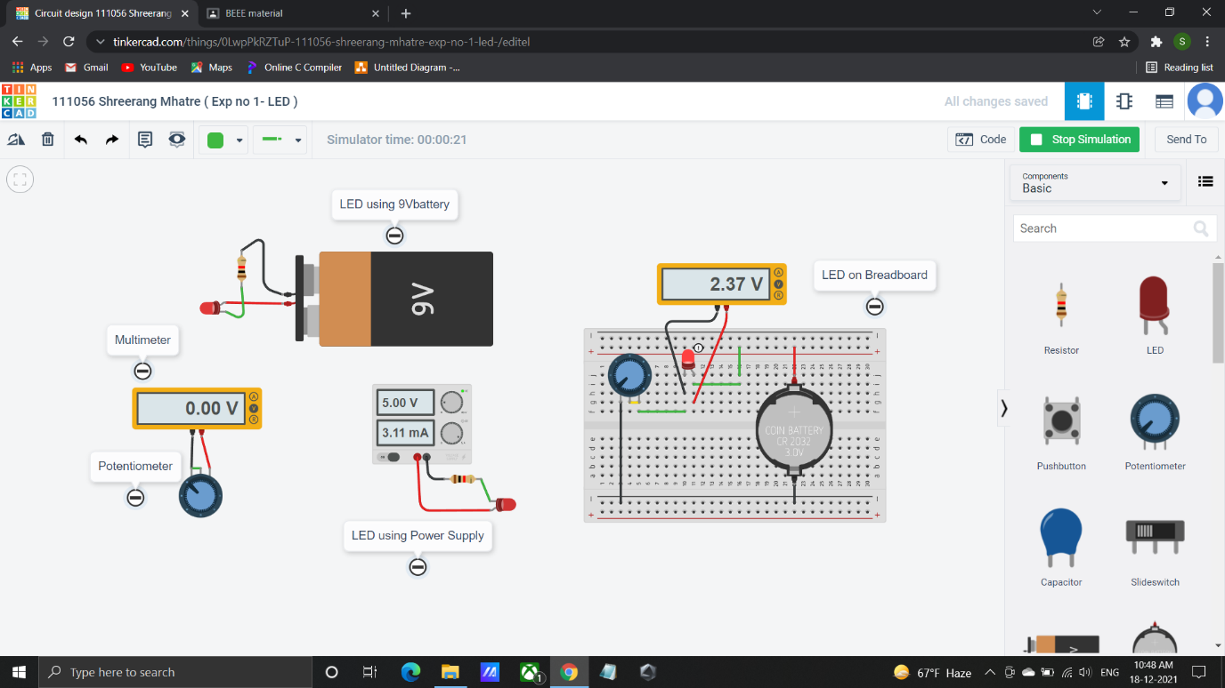

* **DC Motor (Clockwise) using Photoresistor**

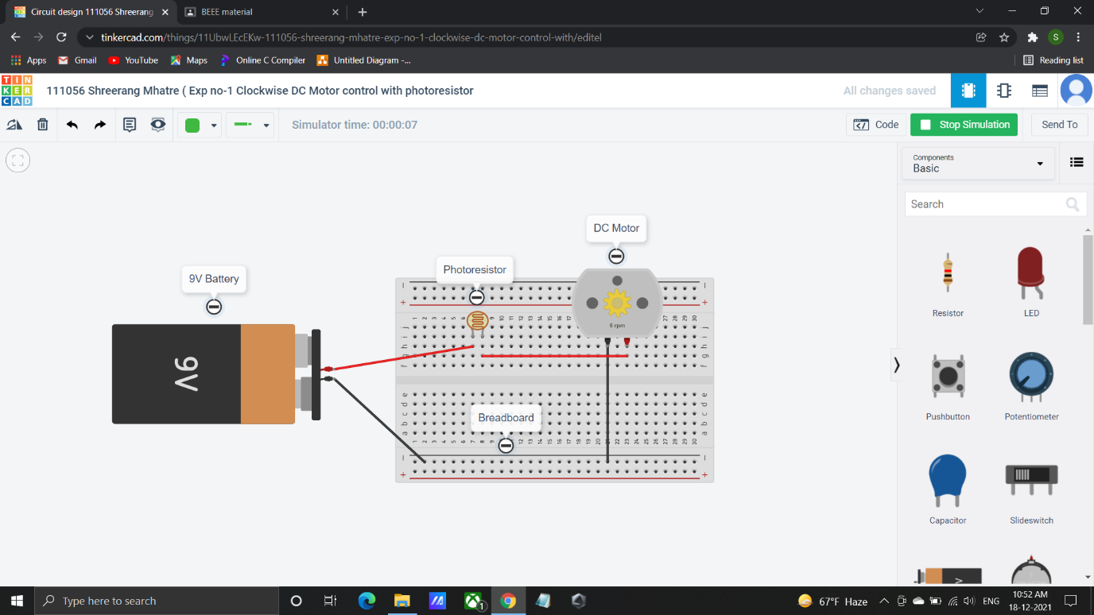

* **DC Motor (Anticlockwise) using Photoresistor**

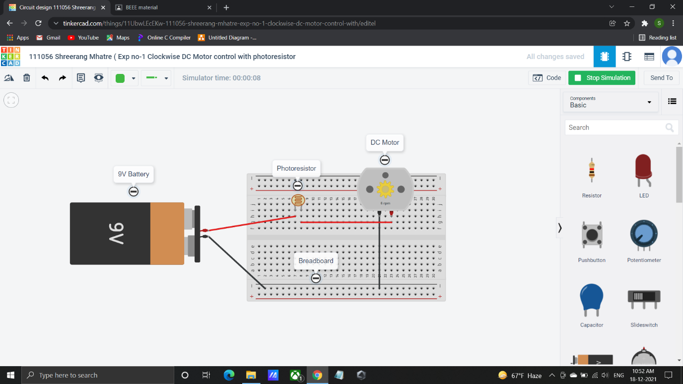

**Post Lab Questions:**

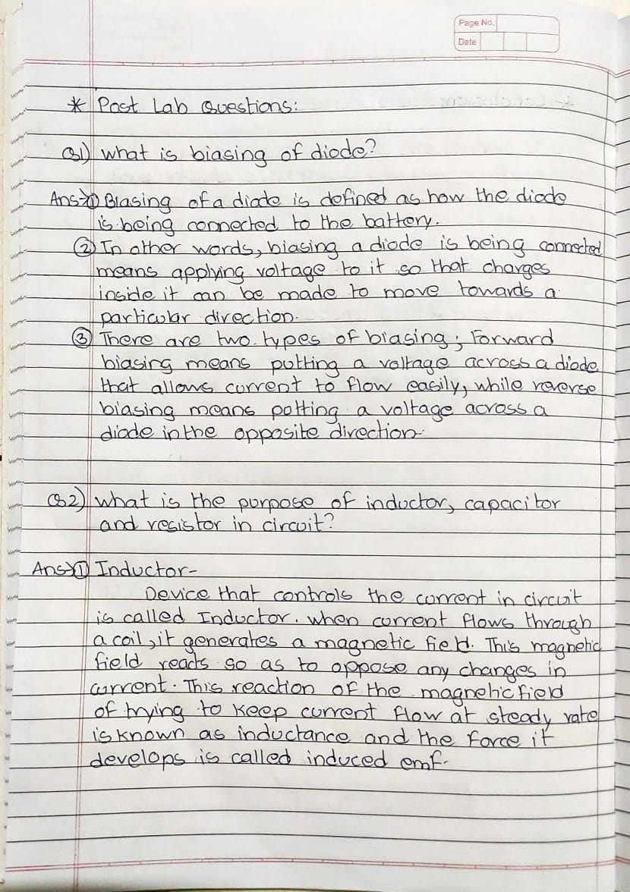

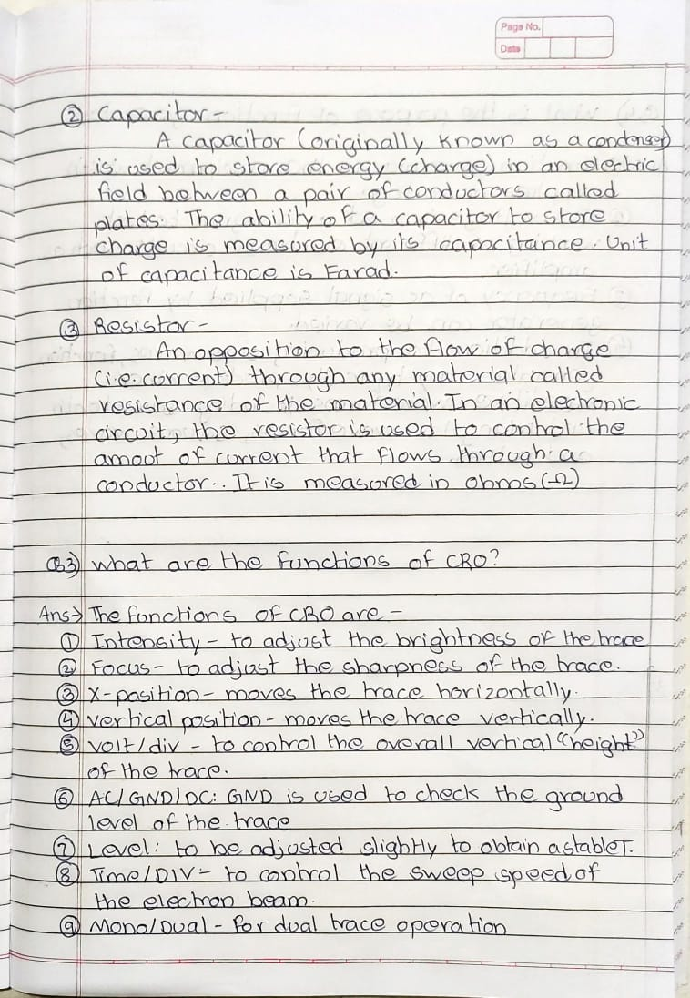

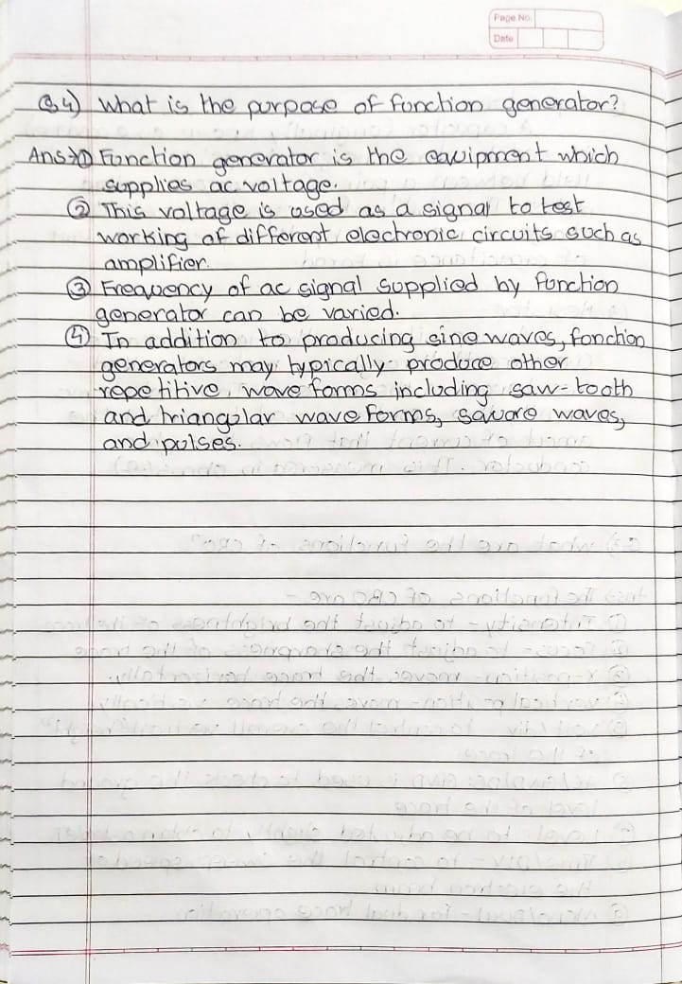

**Additional links for more information:**

* http://vlabs.iitkgp.ernet.in/be/index.html#
* <https://www.youtube.com/watch?v=XdFw-5_XyOI>
* <https://infonics.files.wordpress.com/2015/03/familiarisation-of-electronic-components-and-equipments.pdf>

**LABORATORY CONTINUOUS ASSESSMENT RUBRIC**

**F.Y. B.Tech. Academic Year 2020-21 Trimester:**

**Course: Basics of Electrical and Electronics Engineering Expt. No.: Evaluator: Date:**

**Name of Student:**

|  |  |  |  |  |  |  |
| --- | --- | --- | --- | --- | --- | --- |
| **DIMENSION** | **SCALE** | | | | | **SCORE** |
| **1** | **2** | **3** | **4** | **5** |
| **Regularity and punctuality** | Did not Perform/ submit | Performed and submitted later than scheduled date with permission | Performed on schedule; submitted two weeks late | Performed on schedule; submitted one week late | Performed and submitted as per schedule |  |
| **Understanding the objective and Procedure** | Cannot follow the procedure according to objective | Follows procedure half-heartedly | Follows right procedure; but cannot analyze data and interpret it | Follows right procedure but can analyze data and interpret it | Follows right procedure; can analyze data and interpret it with justification |  |
| **Participation and Implementation Skills** | Does not participate in experiment | Performs the experiment only with the help from supervisor/others and is confused and untidy. | Performs the experiment with some supervisory help; but forgets some crucial reading and is confused and untidy. | Performs experiment on own without supervisory help; records all readings properly but untidy. | Performs experiment on his/her own without supervisory help; records all readings properly. Keeps the setup clean and tidy. |  |
| **Ethics** | Copies the results from others | Completes the result analysis with help from others but forgets to acknowledge the help. | Completes the result analysis with help from others and acknowledges the help. | Produces his own result analysis but blames others for any inadequacy found during the examination | Produces his own result analysis faithfully and owns up the results without any manipulation |  |
| Total | | | | | |  |
| Teacher’s signature with date: Student’s signature with date: | | | | | | |